Positive Voice of Employee Examples

Example 1
Source: Glassdoor
Image/Screenshot:
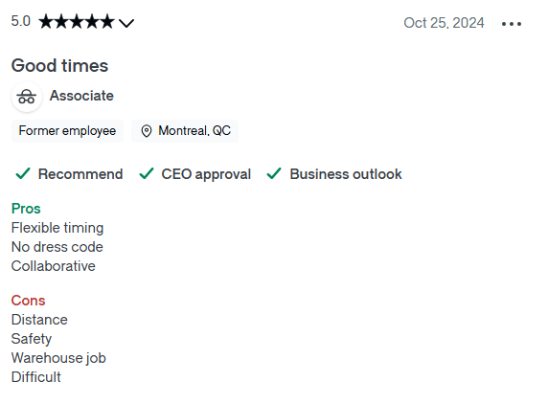
Link: https://www.glassdoor.ca/Reviews/Employee-Review-Amazon-Fulfillment-Center-E7920371-RVW92279662.htm

Why its a bad review: This review is not very detailed which makes it difficult for the reader to identify root causes or take action for issues listed.

Actions to be taken: Continue to provide flexibility in shift timings and maintain a collaborative work environment. Implement additional safety measures and training to maintain safety of all workers on site. Implement additional training programs and engage employees in training to ensure work is easy and clear.

Example 2
Source: Glassdoor
Image/Screenshot:
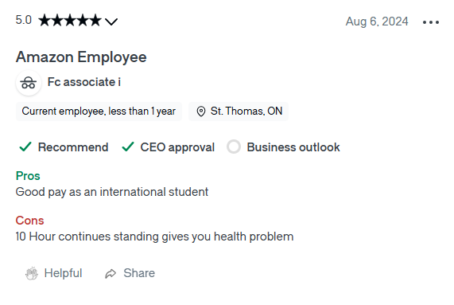
Link: https://www.glassdoor.ca/Reviews/Employee-Review-Amazon-Fulfillment-Center-E7920371-RVW89822109.htm

Why its a good review: This review clearly indicates the positive and negative experience associated with their time at Amazon fulfillment centers using full sentences.

Actions to be taken: Continue providing the pay being offered currently and investigate options for sitting and performing tasks to minimize time spent standing continuously to support employee health.

Example 3
Source: Glassdoor
Image/Screenshot:
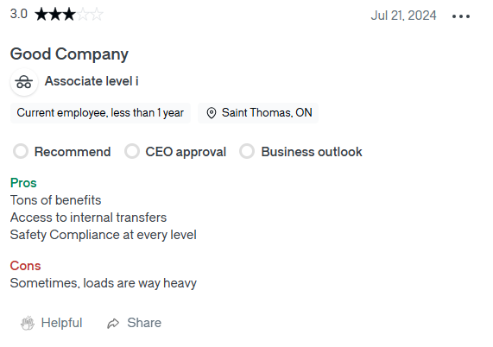
Link: https://www.glassdoor.ca/Reviews/Employee-Review-Amazon-Fulfillment-Center-E7920371-RVW89346202.htm

Why its a good review: This review gives some details about the positive and negative points of working at Amazon fulfillment centers which provide insight into which policies need to be continued and which ones need to be changed.

Actions to be taken: Continue to offer internal transfers and maintain the safety compliance standards at every level. Investigate methods of easing loads carried by employees to ensure safety and ease of work.

Negative Voice of Employee Examples

Example 1
Source: Glassdoor
Image/Screenshot: Customer Service Representative, posted 8 months ago
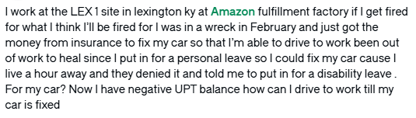
Link: https://www.glassdoor.ca/Community/the-worklife-bowl/i-work-at-the-lex-1-site-in-lexington-ky-at-amazon-fulfillment-factory-if-i-get-fired-for-what-i-think-ill-be-fired-for-i-was-in

Why its a good review: This is a detailed review expressing the employee’s frustration with the management and their leave policies.

Actions to be taken: Based on the details of this incident, upper management can identify problematic policies or staff and take appropriate action.

Example 2
Source: Glassdoor
Image/Screenshot:
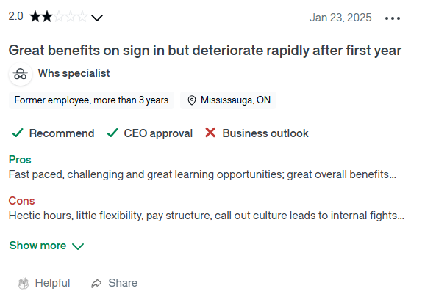
Link: https://www.glassdoor.ca/Reviews/Employee-Review-Amazon-Fulfillment-Center-E7920371-RVW94559715.htm

Why its a bad review: This review does not provide much detail on the advantages and disadvantages listed of working at the Amazon fulfillment center.

Actions to be taken:

Example 3
Source: Glassdoor
Image/Screenshot:
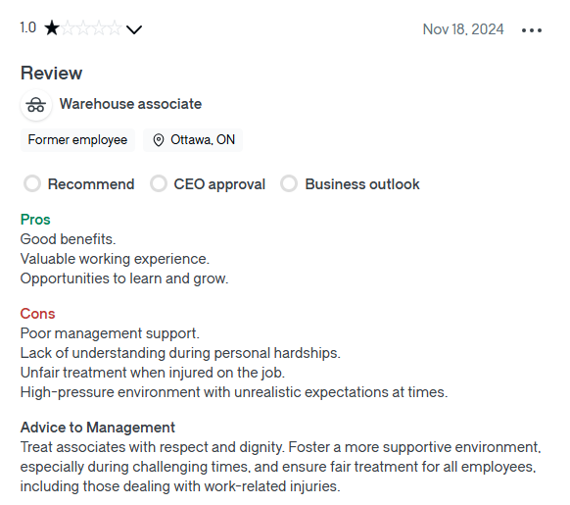
Link: https://www.glassdoor.ca/Reviews/Employee-Review-Amazon-Fulfillment-Center-E7920371-RVW92956440.htm

Why its a good review: This review provides detailed insight into the advantages and disadvantages of working at the center. They also provide actionable advice to the management which can be used to improve hiring and training staff.

Actions to be taken: Investigate management staff practices especially related to injuries at work and implement additional training courses or replace problematic staff as appropriate.

